**Sync slicers**

In this task you will sync the **Year** and **Region** slicers.

*You will continue the development of the report created in the****Design a Report in Power BI Desktop, Part 1****lab.*

1. In Power BI Desktop, on the **Overview** page, set the **Year** slicer to **FY2018**.
2. Go to the **My Performance** page, and then notice that the **Year** slicer is a different value.

*When slicers aren’t synced it can contribute to misrepresentation of data and frustration for report users. You’ll now sync the report slicers.*

1. Return to the **Overview** page, and then select the **Year** slicer.
2. On the **View** ribbon tab, from inside the **Show Panes** group, click **Sync Slicers**.

[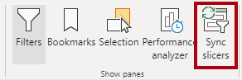](https://github.com/MicrosoftLearning/DA-100-Analyzing-Data-with-Power-BI/blob/master/Instructions/Labs/Linked_image_Files/08-design-report-in-power-bi-desktop-enhanced_image13.png)

1. In the **Sync Slicers** pane (at the left of the **Visualizations** pane), in the second column (which represents syncing), check the checkboxes for the **Overview** and **My Performance** pages.

[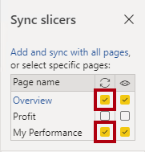](https://github.com/MicrosoftLearning/DA-100-Analyzing-Data-with-Power-BI/blob/master/Instructions/Labs/Linked_image_Files/08-design-report-in-power-bi-desktop-enhanced_image14.png)

1. On the **Overview** page, select the **Region** slicer.
2. Sync the slicer with the **Overview** and **Profit** pages.

[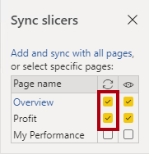](https://github.com/MicrosoftLearning/DA-100-Analyzing-Data-with-Power-BI/blob/master/Instructions/Labs/Linked_image_Files/08-design-report-in-power-bi-desktop-enhanced_image15.png)

1. Test the sync slicers by selecting different filter options, and then verifying that the synced slicers filter by the same selection.
2. To close the **Sync Slicer** page, click the **X** located at the top-right of the pane.

[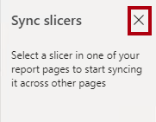](https://github.com/MicrosoftLearning/DA-100-Analyzing-Data-with-Power-BI/blob/master/Instructions/Labs/Linked_image_Files/08-design-report-in-power-bi-desktop-enhanced_image16.png)

**Exercise 2: Configure Drill Through**

In this exercise you will create a new page and configure it as a drill through page. When you’ve completed the design, the page will look like the following:

[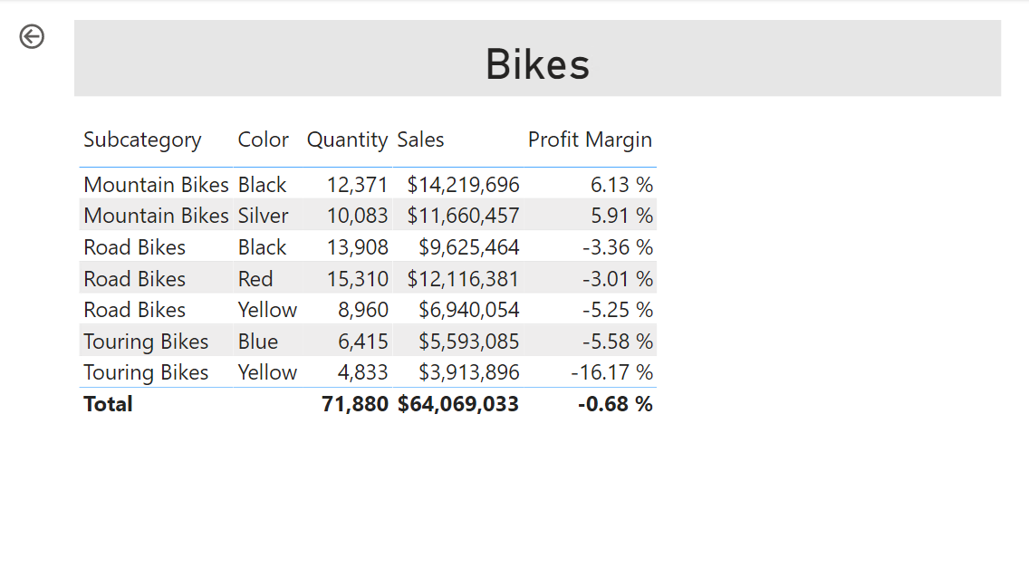](https://github.com/MicrosoftLearning/DA-100-Analyzing-Data-with-Power-BI/blob/master/Instructions/Labs/Linked_image_Files/08-design-report-in-power-bi-desktop-enhanced_image17.png)

**Create a drill through page**

In this task you will create a new page and configure it as a drill through page.

1. Add a new report page named **Product Details**.

[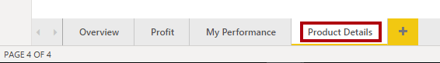](https://github.com/MicrosoftLearning/DA-100-Analyzing-Data-with-Power-BI/blob/master/Instructions/Labs/Linked_image_Files/08-design-report-in-power-bi-desktop-enhanced_image18.png)

1. Right-click the **Product Details** page tab, and then select **Hide Page**.

[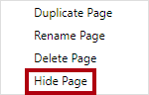](https://github.com/MicrosoftLearning/DA-100-Analyzing-Data-with-Power-BI/blob/master/Instructions/Labs/Linked_image_Files/08-design-report-in-power-bi-desktop-enhanced_image19.png)

*Report users won’t be able to go to the drill through page directly. They’ll need to access it from visuals on other pages. You’ll learn how to drill through to the page in the final exercise of this lab.*

1. Beneath the **Visualizations** pane, in the **Drill Through** section, add the **Product | Category** field to the **Add Drill-Through Fields Here** box.

*The labs use a shorthand notation to reference a field. It will look like this:****Product | Category****. In this example,****Product****is the table name and****Category****is the field name.*

[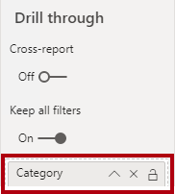](https://github.com/MicrosoftLearning/DA-100-Analyzing-Data-with-Power-BI/blob/master/Instructions/Labs/Linked_image_Files/08-design-report-in-power-bi-desktop-enhanced_image20.png)

1. To test the drill through page, in the drill through filter card, select **Bikes**.

[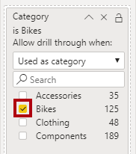](https://github.com/MicrosoftLearning/DA-100-Analyzing-Data-with-Power-BI/blob/master/Instructions/Labs/Linked_image_Files/08-design-report-in-power-bi-desktop-enhanced_image21.png)

1. At the top-left of the report page, notice the arrow button.

[Picture 100](https://github.com/MicrosoftLearning/DA-100-Analyzing-Data-with-Power-BI/blob/master/Instructions/Labs/Linked_image_Files/08-design-report-in-power-bi-desktop-enhanced_image22.png)

*A button is added automatically when a field is added to the drill through well. It allows report users to navigate back to the page from which they drilled through.*

1. Add a **Card** visual to the page, and then resize and position it so it sits to the right of the button and fills the remaining width of the page.

[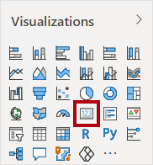](https://github.com/MicrosoftLearning/DA-100-Analyzing-Data-with-Power-BI/blob/master/Instructions/Labs/Linked_image_Files/08-design-report-in-power-bi-desktop-enhanced_image23.png)

[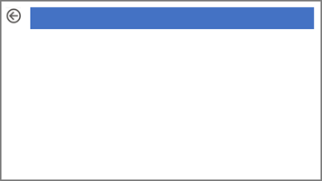](https://github.com/MicrosoftLearning/DA-100-Analyzing-Data-with-Power-BI/blob/master/Instructions/Labs/Linked_image_Files/08-design-report-in-power-bi-desktop-enhanced_image24.png)

1. Drag the **Product | Category** field into the card visual.
2. Configure the format options for the visual, and then turn the **Category Label** property to **Off**.

[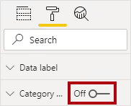](https://github.com/MicrosoftLearning/DA-100-Analyzing-Data-with-Power-BI/blob/master/Instructions/Labs/Linked_image_Files/08-design-report-in-power-bi-desktop-enhanced_image25.png)

1. Set the **Background Color** property to a light shade of gray.
2. Add a **Table** visual to the page, and then resize and position it so it sits beneath the card visual and fills the remaining space on the page.

[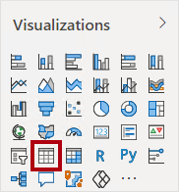](https://github.com/MicrosoftLearning/DA-100-Analyzing-Data-with-Power-BI/blob/master/Instructions/Labs/Linked_image_Files/08-design-report-in-power-bi-desktop-enhanced_image26.png)

[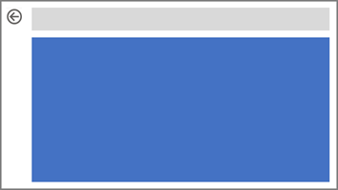](https://github.com/MicrosoftLearning/DA-100-Analyzing-Data-with-Power-BI/blob/master/Instructions/Labs/Linked_image_Files/08-design-report-in-power-bi-desktop-enhanced_image27.png)

1. Add the following fields to the visual:
   * Product | Subcategory
   * Product | Color
   * Sales | Quantity
   * Sales | Sales
   * Sales | Profit Margin
2. Configure the format options for the visual, and in the **Grid** section, set the **Text Size** property to **20pt**.

*The design of the drill through page is almost complete. You’ll enhance the page with conditional formatting in the next exercise.*

**Exercise 3: Add Conditional Formatting**

In this exercise you will enhance the drill through page with conditional formatting. When you’ve completed the design, the page will look like the following:

[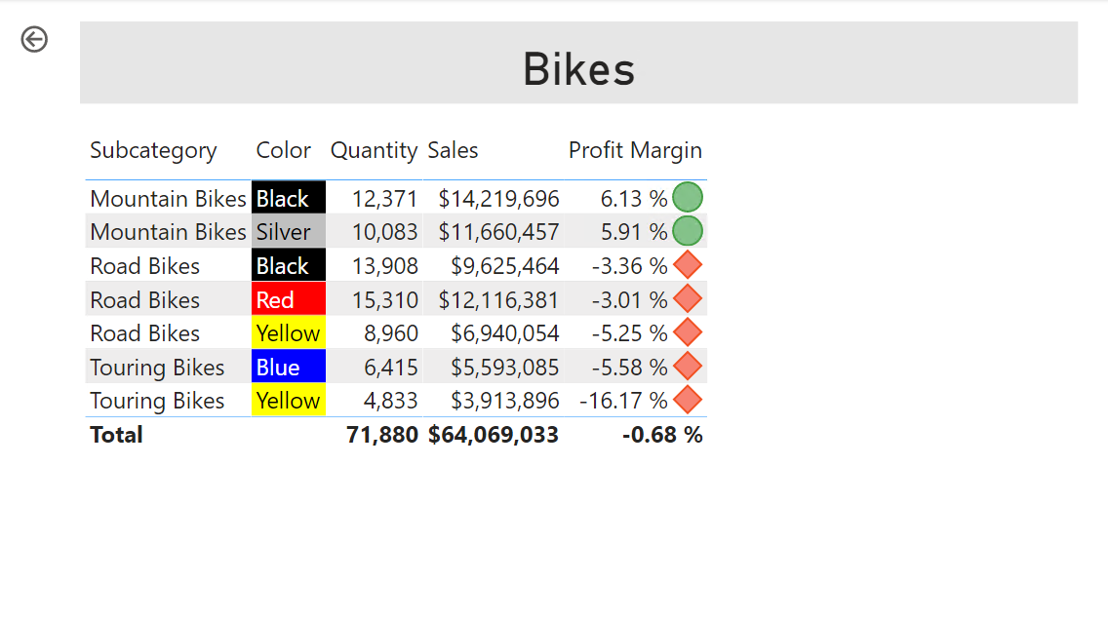](https://github.com/MicrosoftLearning/DA-100-Analyzing-Data-with-Power-BI/blob/master/Instructions/Labs/Linked_image_Files/08-design-report-in-power-bi-desktop-enhanced_image28.png)

**Add conditional formatting**

In this task you will enhance the drill through page with conditional formatting.

1. Select the table visual.
2. In the visualization pane, click the down-arrow on the **Profit Margin** value, and then select **Conditional Formatting | Icons**.

[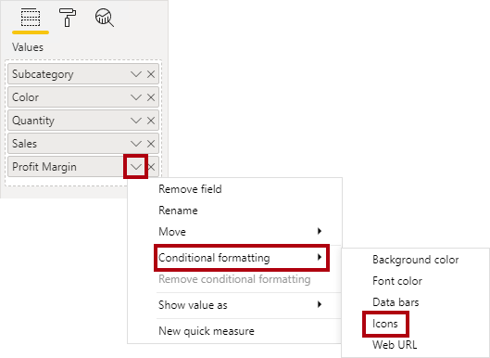](https://github.com/MicrosoftLearning/DA-100-Analyzing-Data-with-Power-BI/blob/master/Instructions/Labs/Linked_image_Files/08-design-report-in-power-bi-desktop-enhanced_image29.png)

1. In the **Icons – Profit Margin** window, in the **Icon Layout** dropdown list, select **Right of Data**.

[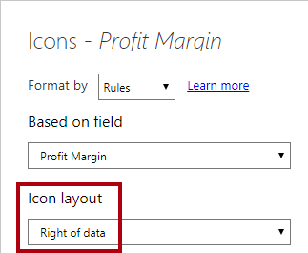](https://github.com/MicrosoftLearning/DA-100-Analyzing-Data-with-Power-BI/blob/master/Instructions/Labs/Linked_image_Files/08-design-report-in-power-bi-desktop-enhanced_image30.png)

1. To delete the middle rule, at the left of the yellow triangle, click **X**.

[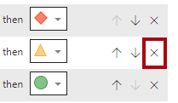](https://github.com/MicrosoftLearning/DA-100-Analyzing-Data-with-Power-BI/blob/master/Instructions/Labs/Linked_image_Files/08-design-report-in-power-bi-desktop-enhanced_image31.png)

1. Configure the first rule (red diamond) as follows:
   * In the second control, remove the value
   * In the third control, select **Number**
   * In the fifth control, enter **0**
   * In the sixth control, select **Number**
2. Configure the second rule (green circle) as follows:
   * In the second control, enter **0**
   * In the third control, select **Number**
   * In the fifth control, remove the value
   * In the sixth control, select **Number**

[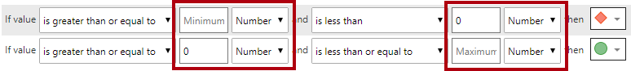](https://github.com/MicrosoftLearning/DA-100-Analyzing-Data-with-Power-BI/blob/master/Instructions/Labs/Linked_image_Files/08-design-report-in-power-bi-desktop-enhanced_image32.png)

*The rules can be interpreted as follows: display a red diamond if the profit margin value is less than 0; otherwise if the value is great or equal to zero, display a green circle.*

1. Click **OK**.

[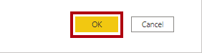](https://github.com/MicrosoftLearning/DA-100-Analyzing-Data-with-Power-BI/blob/master/Instructions/Labs/Linked_image_Files/08-design-report-in-power-bi-desktop-enhanced_image33.png)

1. In the table visual, verify that the that the correct icons are displayed.

[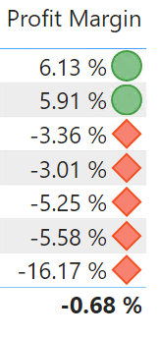](https://github.com/MicrosoftLearning/DA-100-Analyzing-Data-with-Power-BI/blob/master/Instructions/Labs/Linked_image_Files/08-design-report-in-power-bi-desktop-enhanced_image34.png)

1. Configure background color conditional formatting for the **Color** field.
2. In the **Background Color – Color** window, in the **Format By** dropdown list, select **Field Value**.

[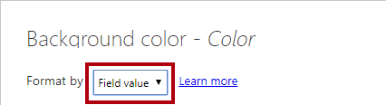](https://github.com/MicrosoftLearning/DA-100-Analyzing-Data-with-Power-BI/blob/master/Instructions/Labs/Linked_image_Files/08-design-report-in-power-bi-desktop-enhanced_image35.png)

1. In the **Based on Field** dropdown list, select **Product | Formatting | Background Color Format**.

[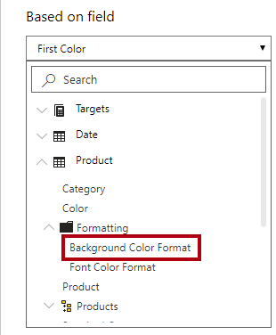](https://github.com/MicrosoftLearning/DA-100-Analyzing-Data-with-Power-BI/blob/master/Instructions/Labs/Linked_image_Files/08-design-report-in-power-bi-desktop-enhanced_image36.png)

1. Click **OK**.

[](https://github.com/MicrosoftLearning/DA-100-Analyzing-Data-with-Power-BI/blob/master/Instructions/Labs/Linked_image_Files/08-design-report-in-power-bi-desktop-enhanced_image37.png)

1. Repeat the previous steps to configure font color conditional formatting for the **Color** field, using the **Product | Formatting | Font Color Format** field